Step 1. Find the Node-RED Starter Kit in the IBM Cloud catalog

1. Log in to [IBM Cloud](https://cloud.ibm.com/login?cm_sp=ibmdev-_-developer-tutorials-_-cloudreg).
2. Open the catalog and search for **node-red**.
3. Click on the **Node-RED App** tile.

This will show you an overview of the Starter Kit and what it provides.

Step 2. Create your application

Now you need to create the Node-RED starter application.

1. On the *Create* tab, a randomly generated **App name** will be suggested. Either accept that default name or provide a unique name for your application. This will become part of the application URL.

***Note:*** If the name is not unique, you will see an error message and you must enter a different name before you can continue.

1. The Node-RED starter application requires an instance of the **Cloudant database service** with IBM Cloud IAM and Cloudant credentials to store your application flow configuration. Select the region the service should be created in and what pricing plan it should use.

***Note:*** You can only have one Cloudant instance using the Cloudant Lite plan. If you have already got an instance, you will be able to select it from the **Pricing plan** select box. You can have more than one Node-RED starter application using the same Cloudant service instance.

1. Click the **Create** button to continue. This will create your application and, if necessary a Cloudant database service instance, but it is not yet deployed to IBM Cloud.

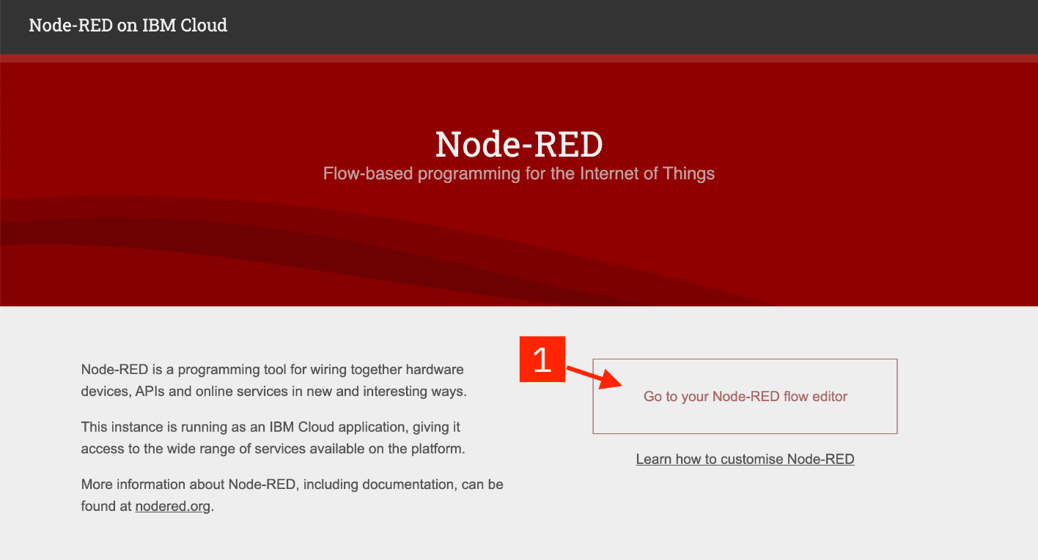

Step 3. Enable the Continuous Delivery feature

At this point, you have created the application and the resources it requires, but you have not deployed it anywhere to run. This step shows how to setup the Continuous Delivery feature that will deploy your application into the **Code Engine** space of IBM Cloud.

1. On the next screen, click the **Deploy your app** button to enable the *Continuous Delivery* feature for your application.
2. On the next screen, click the **Code Engine** tile.
3. Scroll down after selecting the **Code Engine** tile. You will need to create an **IBM Cloud API** key to allow the deployment process to access your resources. Click the **New** button to create the key. A message dialog will appear. You can accept the default values and confirm to close the dialog.
4. Select the **Region** and **Container registry region**, to deploy your application to. This should match the region you created your Cloudant instance in.
5. Provide a unique **Project** name or accept the default 'project-name'

Click **Next** to continue.

1. Configure the **DevOps toolchain** by selecting the **region** it should be created in. Again, try to match the region you selected previously.

Click **Create**. This will take you back to the application details page. The application details page gives you a useful overview of your application including details of its external URL and the additional services it is connected to. Bookmark this page as you'll need to come back to it later.

1. After a few moments, the **Deployment Automation** section will refresh with the details of your newly created Delivery Pipeline. The Status field of the pipeline will eventually show **In progress**. That means your application is being built and deployed.
2. The Deploy stage will take a few minutes to complete. You can click on the ci-pipeline **Status** link to check the progress of the Delivery Pipeline. Eventually the Deploy stage will display a green checkmark and a **Success** message to show it has passed. This means your Node-RED starter application is now running.

Step 4. Open the Node-RED application

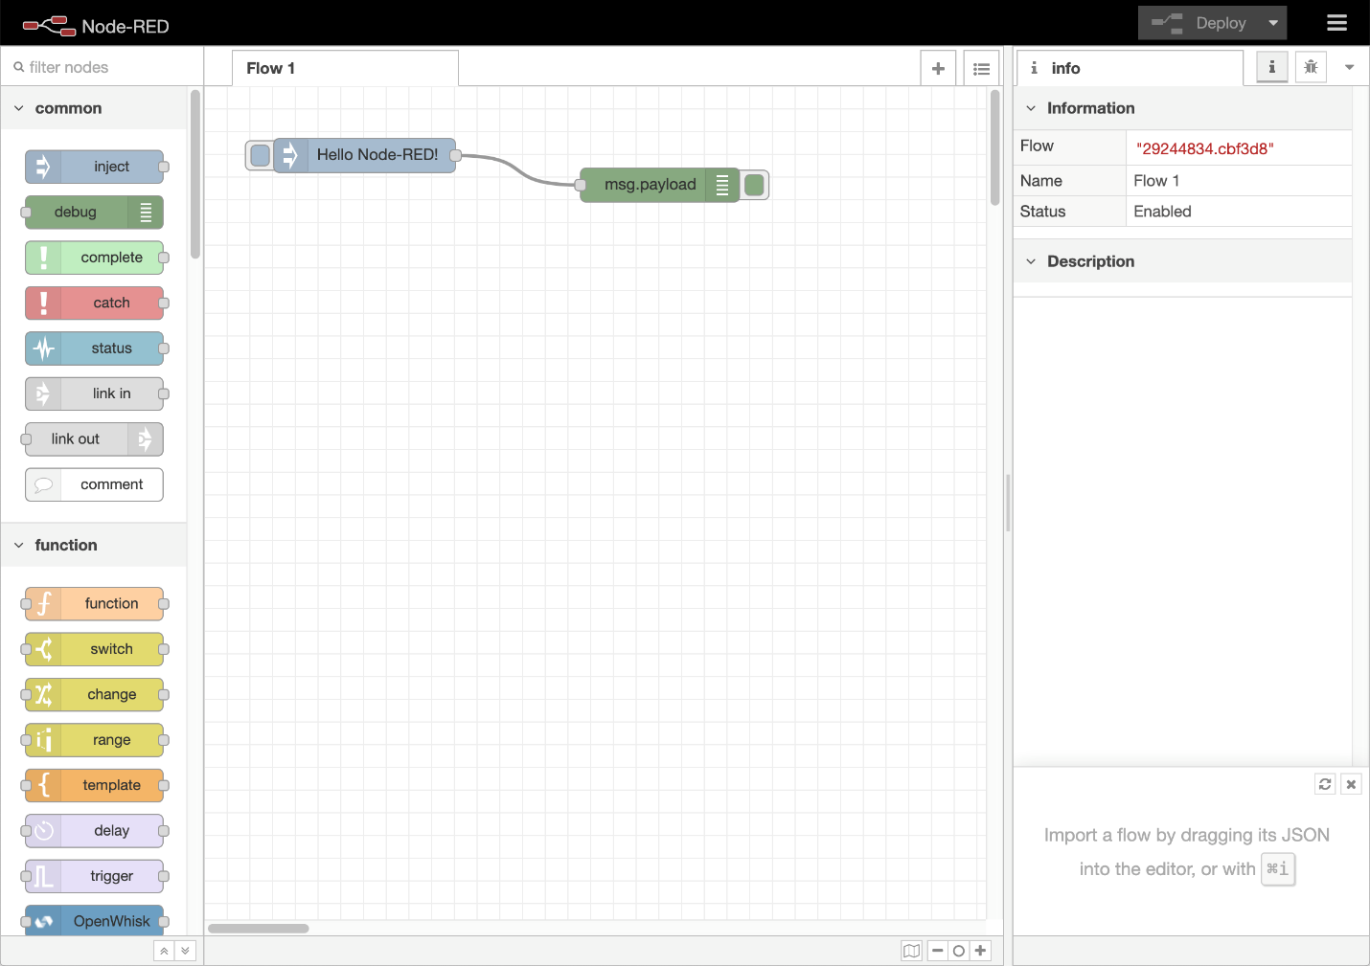

Now that you've deployed your Node-RED application, let's open it up! You may have to refresh your page.

On the application details page, you should now see the **App URL**, **Source** and **Deployment target** fields filled in.

Click on the **App URL** to open up your Node-RED application in a new browser tab.

Step 5. Configure your Node-RED application

The first time you open your Node-RED app, you'll need to configure it and set up security.

1. A new browser tab will open with the Node-RED start page.
2. On the initial screen, click **Next** to continue.
3. Secure your Node-RED editor by providing a **username** and **password**. If you need to change these at any point, you can either edit the values in the Cloudant database, or override them using *environment variables*. The documentation on [nodered.org](https://nodered.org/docs/getting-started/ibmcloud) describes how to do this. Click **Next** to continue.
4. The final screen summarizes the options you've made and highlights the environment variables you can use to change the options in the future. Click **Finish** to proceed.
5. Node-RED will save your changes and then load the main application. From here you can click the **Go to your Node-RED flow editor** button to open the editor.

The Node-RED editor opens showing the default flow.

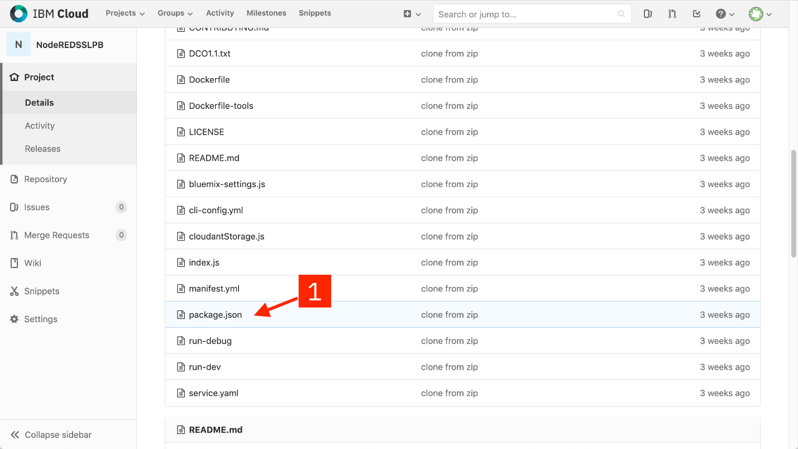

Step 6. Add extra nodes to your Node-RED palette

Node-RED provides the palette manager feature that allows you to install additional nodes directly from the browser-based editor. This is convenient for trying nodes out, but it can cause issues due to the limited memory of the default Node-RED starter application.

The recommended approach is to edit your application's package.json file to include the additional node modules and then redeploy the application.

This step shows how to do that in order to add the [**node-red-dashboard**](https://flows.nodered.org/node/node-red-dashboard) module.

1. On your application's details page, click **Source** url. This will take you to a git repository where you can edit the application source code from your browser.
2. Scroll down the list of files and click on **package.json**. This file lists the module dependencies of your application.
3. Click the **Edit** button
4. Add the following entry to the top of the dependencies section (1):

"node-red-dashboard": "2.x",